**SYOPI**

**An E-Commerce Web Service**

**IS213 Project**

**Enterprise Solution Development**

**G3 - T1**

**Alexander Vincent Lewi**

**Emily Aurelia**

**Jordian Renaldi**

**Vincent Wesley**

**Vitto Surya Tedja**

**Yozafard Harold Siauheming**

# Introduction

Our project, Syopi, aims to tackle how an e-commerce site with lots of moving components would work in a microservice architecture. The two main actors in an e-commerce system are customers and sellers. Our user scenarios revolve around these actors.

The first scenario is focused on how a customer would land on our application and browse the product that they like and then make payment and officially create an order in our application.

Our second scenario is focused on the user who can sign up as a seller and set up their own shop, add products and then later receive orders from customers.

Lastly, our third scenario follows along the storyline where the product that a user has bought arrived safely into their doorstep and they wanted to rate the product, letting the seller know how well they perform.

# User Scenarios

## Customer browse and purchase product

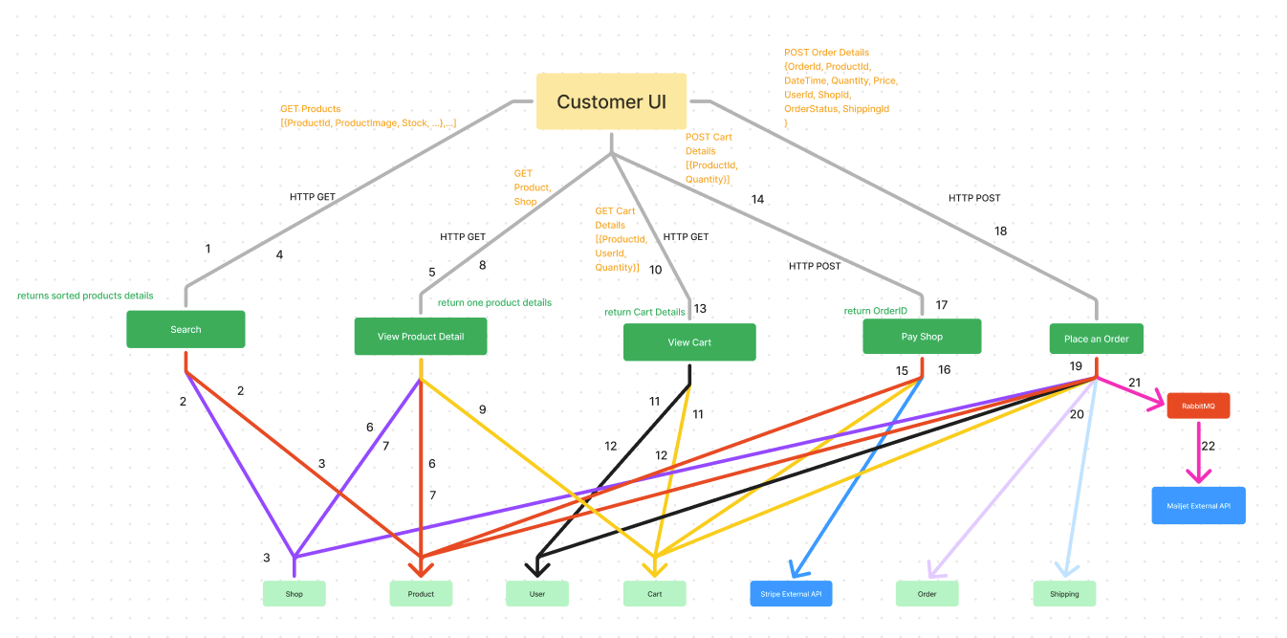

***Customer browse and purchase product - Microservice Interaction Diagram***

Customer browse and purchase product:

1. When UI loads, it calls Search Complex Microservice to get recommended products
2. Search will call product and store to get the necessary information that they need to recommend best products to the customer
3. Both microservices will send the data back by HTTP GET
4. Search returns back 10 most recommended products
5. When user clicks on one of the product card, UI request for View Product Detail Microservice
6. View Product Detail will fetch necessary information from product and shop
7. Product and Shop returns back needed data
8. View Product Details return product details to UI
9. When user click add to cart, View Product detail POST a request to cart containing ProductID and Quantity
10. When customer clicks on cart button, View Cart is called to fetch the necessary details
11. View Cart calls user and Cart to find a specific user’s cart
12. User and Cart sends back data
13. View Cart shows detail of Cart
14. When user press Checkout, Pay Shop is called
15. Pay Shop calls product, cart, and Stripe API to create payment Intent
16. All microservice returns necessary data
17. Pay Shop returns payment_intent as OrderID and redirects to success page
18. UI calls Place An Order
19. Place Order calls Shop, Product, User, Order and Shipping to create an order record, and at the same time removes all data in user’s cart
20. Order Record is created
21. Order Record is sent to RabbitMQ to be snet to Mailjet
22. Mailjet sends email confirmation to user

### External Services

| Service Name | Description of the functionality | Link to external web pages that describe the detailed inputs/outputs |
| --- | --- | --- |
| *Supabase* | *Database to store User, Order, Shop and Product information.* | [*https://supabase.com/*](https://supabase.com/) |
| *Stripe* | *Make Secure Payment and create OrderID* | [*https://stripe.com/docs/api*](https://stripe.com/docs/api) |
| *Mailjet* | *Send Order Info through Mail* | [*https://dev.mailjet.com/*](https://dev.mailjet.com/) |

### Beyond the Labs

## [User Scenario 2]

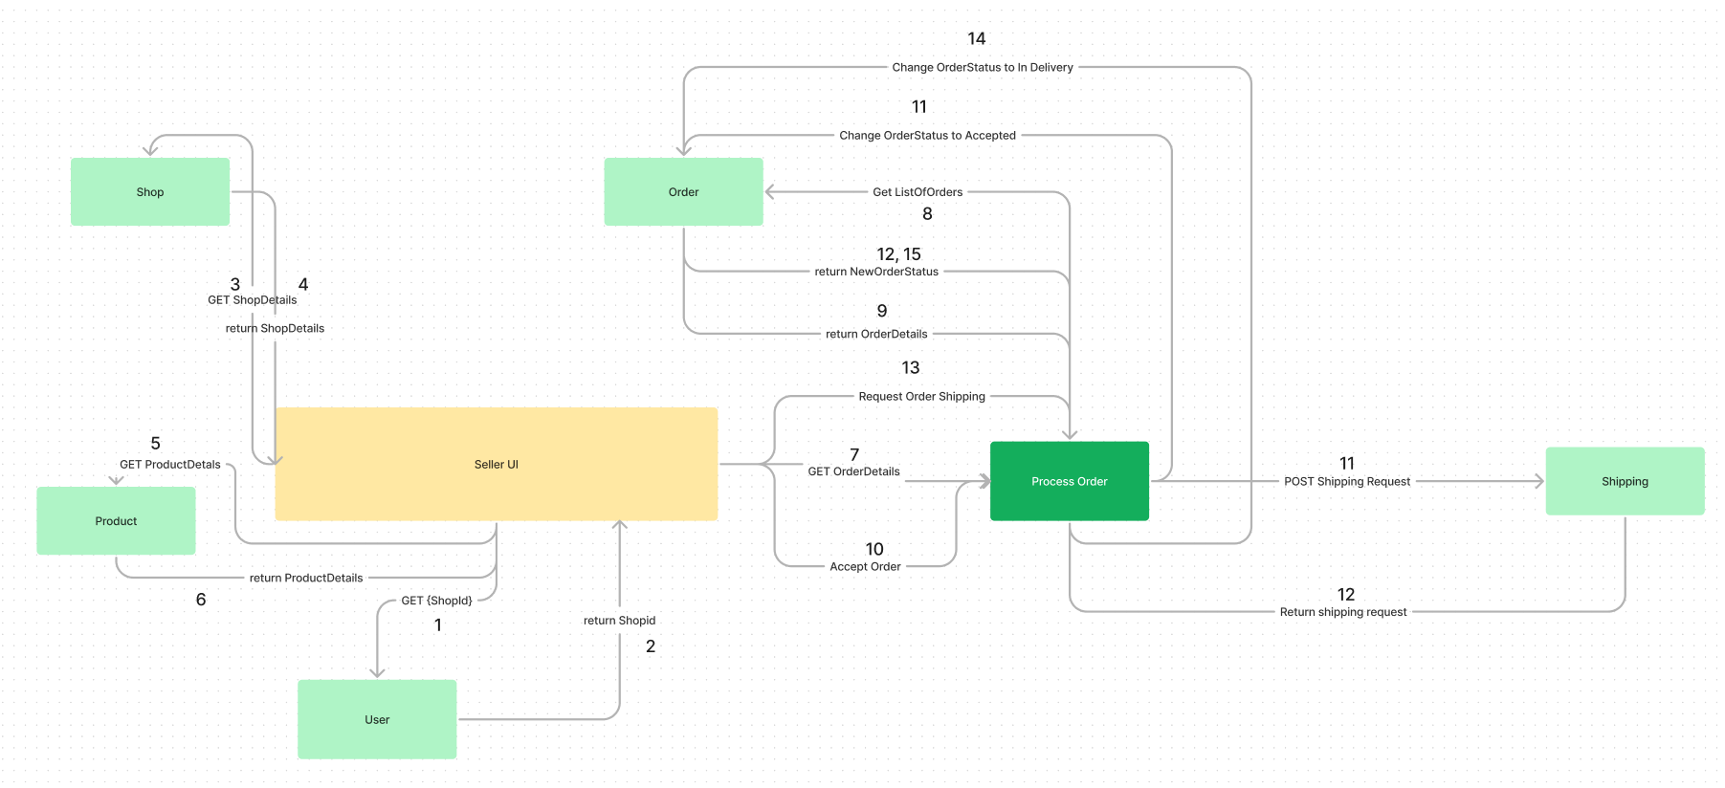

***Process Order- Microservice Interaction Diagram***

Sellers Process Orders:

1. Sellers get their ShopId from the User Database
2. The User Database then returns the ShopId
3. Using the ShopId, the Seller UI then get the ShopDetails from the Shop Database
4. The Shop database will return the ShopDetails and show the details on the Seller UI dashboard
5. Then, it will also retrieve the ProductDetails that the shop is selling by sending the shopId to the Product Database
6. The Product Database will send the ProductDetails to the Seller UI
7. Once the seller goes to the order page, the Seller UI get all the order details from the process order complex microservice
8. ProcessOrder will use the ShopId to retrieve ListOfOrders from Order Database
9. The Order Database then returns all the OrderDetails to the Process Order complex microservice
10. When the seller accepts an order by pressing the ‘Accept Order’ button, the Seller UI will then trigger the Process Order Microservice to update the status of the Order
11. ProcessOrder will then send the Shipping Request to Shipping
12. New order status of “Accepted” is returned
13. Once the status of the Order is
14. j
15. e
16. l
17. e
18. l

### External Services

| Service Name | Description of the functionality | Link to external web pages that describe the detailed inputs/outputs |
| --- | --- | --- |
| *Supabase* | *Database to store User, Order, Shop and Product information.* | [*https://supabase.com/*](https://supabase.com/) |

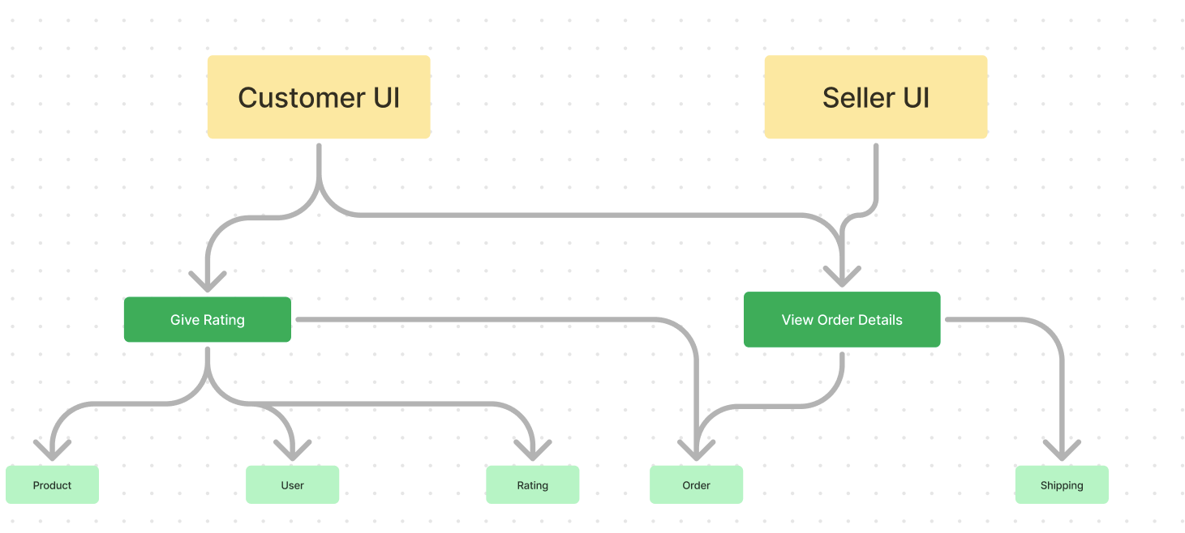

***User reviews product after it arrives - Microservice Interaction Diagram***

User reviews product after it arrives:

1. Seller process order through View Order Details
2. View Order Details updates OrderDB and ShippingDB
3. Once Order is completed, Customer opens order details and accept order
4. Once order is completed, customer can give rating to products bought
5. Customer invokes Give Rating
6. Gives Rating calls product, user, rating and order to show back to UI
7. All the microservices returns necessary data
8. Once UI is done processing the data, customer is going to be able to give rating to delivered order

**Services used**

| Service Name | Description of the functionality | Link to external web pages that describe the detailed inputs/outputs |
| --- | --- | --- |
| *Supabase* | *Database to store User, Order, Shop and Product information.* | [*https://supabase.com/*](https://supabase.com/) |
|  |  |  |

# Overall Beyond The Labs

* ReactJS: Instead of calling Flask API directly to HTML we are using JS framework to make more efficient API calls as components use same properties and therefore lower the number of unnecessary API calls
* Create authentication and user based model to further slim down the amount of data called, making the whole system lighter
* Use Stripe and Mailjet to create a secure connection containing sensitive user data
* Implement different python libraries to optimize search results in different microservices.

# 

# Appendix - Technical Overview Diagram(s) or SOA Layer Diagram(s)

(The appendix is not counted towards the page limit. It is not explicitly graded, but will be used to verify against your solution as described in the report if required.)

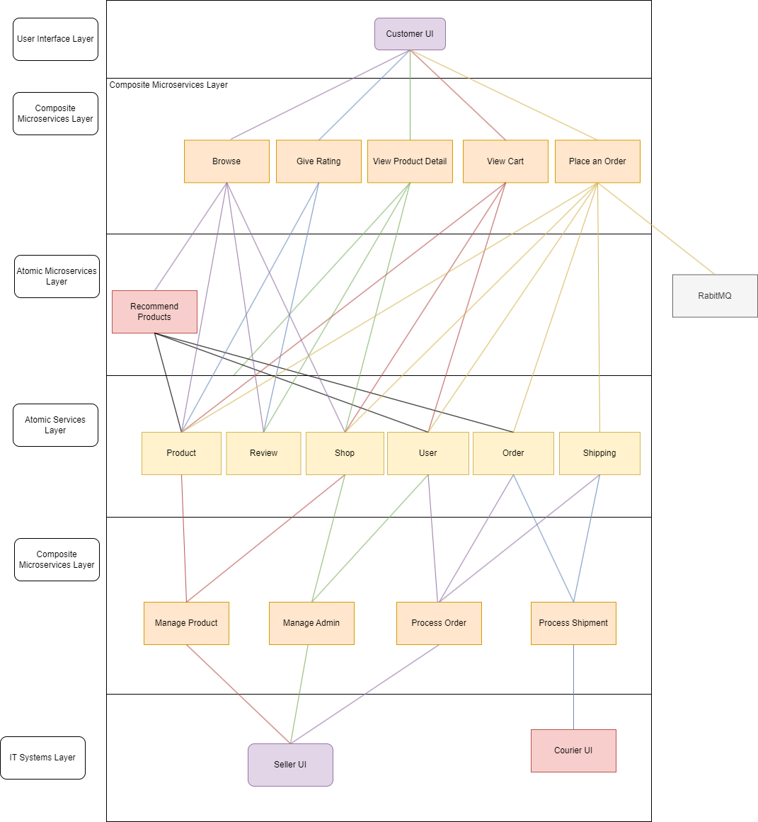

# Appendix - API Docs

Order; HTTP-based API, AMQP-based API:

| GET **/order/get_all_order** – Get all orders | |
| --- | --- |
| Parameters | No parameters |
| Responses | Content type – application/json |
| Code – 200 | Description – successful operation  Example Value  [  {  "DateTime": "2023-04-03T10:02:54.311233+00:00",  "OrderId": "pi_3MskDYBJIMpkY9J20VeP9YY1",  "OrderStatus": "Paid",  "Price": 8.36,  "ProductId": "08d09581-e2b0-451c-83eb-0081d98b20c2",  "Quantity": 1,  "ShippingId": "52b66f93-adaa-40e1-9968-3144d0e483a1",  "ShopId": "9413c28a-3b0b-4955-9ac9-5171a3f8631d",  "UserId": "1"  },  {  "DateTime": "2023-04-03T10:02:54.327096+00:00",  "OrderId": "pi_3MskDYBJIMpkY9J20VeP9YY1",  "OrderStatus": "Paid",  "Price": 7.77,  "ProductId": "af326675-96e0-47f5-9f07-63e97db8098a",  "Quantity": 3,  "ShippingId": "2ae4c2a4-e0c5-42ff-8923-54a808d7950d",  "ShopId": "9413c28a-3b0b-4955-9ac9-5171a3f8631d",  "UserId": "1"  },  {  "DateTime": "2023-04-03T10:14:53.230732+00:00",  "OrderId": "pi_3MskPDBJIMpkY9J21aABW8lS",  "OrderStatus": "Accepted",  "Price": 58.52,  "ProductId": "08d09581-e2b0-451c-83eb-0081d98b20c2",  "Quantity": 7,  "ShippingId": "7b484b6b-bb33-41ac-9130-1ff6430fa537",  "ShopId": "9413c28a-3b0b-4955-9ac9-5171a3f8631d",  "UserId": "1"  }  ] |
| Code – 404 | Description – no orders  Example Value  {  "code": 404,  "message": "There are no orders."  } |
|  |  |
| GET **/order/find_by_orderid/<string:OrderId>** – Find order by order id | |
| Parameters |  |
| Name | <string:OrderId> |
| OrderId  string  *(path)* | Order id of order to return  Example Value  pi_3MskDYBJIMpkY9J20VeP9YY1 |
| Responses | Content type – application/json |
| Code – 200 | Description – successful operation  Example Value  [  {  "DateTime": "2023-04-03T10:02:54.311233+00:00",  "OrderId": "pi_3MskDYBJIMpkY9J20VeP9YY1",  "OrderStatus": "Paid",  "Price": 8.36,  "ProductId": "08d09581-e2b0-451c-83eb-0081d98b20c2",  "Quantity": 1,  "ShippingId": "52b66f93-adaa-40e1-9968-3144d0e483a1",  "ShopId": "9413c28a-3b0b-4955-9ac9-5171a3f8631d",  "UserId": "1"  },  {  "DateTime": "2023-04-03T10:02:54.327096+00:00",  "OrderId": "pi_3MskDYBJIMpkY9J20VeP9YY1",  "OrderStatus": "Paid",  "Price": 7.77,  "ProductId": "af326675-96e0-47f5-9f07-63e97db8098a",  "Quantity": 3,  "ShippingId": "2ae4c2a4-e0c5-42ff-8923-54a808d7950d",  "ShopId": "9413c28a-3b0b-4955-9ac9-5171a3f8631d",  "UserId": "1"  }  ] |
| Code – 404 | Description – Order not found  Example Value  {  "code": 404,  "message": "Order not found."  } |
|  |  |
| POST **/order/create_order** – Create order | |
| Parameters | No parameters |
| Name | Description |
| body  object  *(body)* | Order to create  Example Value  {  "OrderId": "1k2s8fj-gs6aga3kshk",  "ProductId": "08d09581-e2b0-451c-83eb-0081d98b20c2",  "ShopId": "52b66f93-adaa-40e1-9968-3144d0e483a1",  "Quantity": "1",  "Price": "2.81",  "UserId": "1"    } |
| Responses | Content type – application/json |
| Code – 201 | Description – successful operation  Example Value  {  "DateTime": "2023-04-03T17:31:33.199441+00:00",  "OrderId": "1k2s8fj-gs6aga3kshk",  "OrderStatus": "Unpaid",  "Price": 2.81,  "ProductId": "08d09581-e2b0-451c-83eb-0081d98b20c2",  "Quantity": 1,  "ShippingId": "3cef98f4-69ff-44bf-9d5c-61c1a2dbd9aa",  "ShopId": "52b66f93-adaa-40e1-9968-3144d0e483a1",  "UserId": "1"  } |
| Code – 500 | Description – An error occurred creating the order  Example Value  {  "code": 500,  "message": "An error occurred while creating the order.  } |
|  |  |

| POST **/order/accept** – Update order status | |
| --- | --- |
| Parameters | No parameters |
| Name | Description |
| body  object  *(body)* | Order to create  Example Value  {  "OrderId": "1k2s8fj-gs6aga3kshk",  "OrderStatus": "Paid"    } |
| Code – 200 | Description – successful operation  Example Value  [  {  "DateTime": "2023-04-03T17:35:25.382702+00:00",  "OrderId": "1k2s8fj-gs6aga3kshk",  "OrderStatus": "Paid",  "Price": 2.81,  "ProductId": "08d09581-e2b0-451c-83eb-0081d98b20c2",  "Quantity": 1,  "ShippingId": "de08fe31-e1d0-4fe4-a8c6-34f2a24c17f0",  "ShopId": "52b66f93-adaa-40e1-9968-3144d0e483a1",  "UserId": "1"  },  {  "DateTime": "2023-04-03T17:53:20.088433+00:00",  "OrderId": "1k2s8fj-gs6aga3kshk",  "OrderStatus": "Paid",  "Price": 2.81,  "ProductId": "08d09581-e2b0-451c-83eb-0031d98b20c2",  "Quantity": 1,  "ShippingId": "ac70a6db-d52b-4a5c-9fc0-0c08aac864b5",  "ShopId": "52b66f93-adaa-40e1-9968-3144d0e483a1",  "UserId": "1"  }  ] |
| Code – 404 | Description – no orders  Example Value  {  "code": 404,  "message": "There are no orders."  } |
|  |  |

Shop; HTTP-based API:

| GET **/shop** – Get all shops | |
| --- | --- |
| Parameters | No parameters |
| Responses | Content type – application/json |
| Code – 200 | Description – successful operation  Example Value  {  "code": 200,  "data": [  {  "IsActive": "Active",  "ShopAddress": "234 Maple St.",  "ShopId": "b5590f6b-d95e-4675-8ea6-ec1ff54af4f4",  "ShopName": "Target",  "ShopPhoneNumber": "555-3456"  },  {  "IsActive": "Active",  "ShopAddress": "789 Oak St.",  "ShopId": "885cd9dd-ed92-4f12-8c56-315773df07c8",  "ShopName": "Walgreens",  "ShopPhoneNumber": "555-9012"  },  {  "IsActive": "Active",  "ShopAddress": "\"PIK\"",  "ShopId": "a22863a2-6efb-40b2-9279-37bcf03a37c2",  "ShopName": "\"Sanur Mangga Dua\"",  "ShopPhoneNumber": "\"999\""  },  {  "IsActive": "Active",  "ShopAddress": "\"PIK\"",  "ShopId": "93a77f29-cabd-41f7-b2f1-81d3b70d601f",  "ShopName": "\"Sanur Mangga Dua2\"",  "ShopPhoneNumber": "\"999\""  }  ],  "message": "Returning all shops"  } |
| Code – 404 | Description – No products found  Example Value  {  'message': 'No products found.',  "data": None,  "code": 404  } |
|  |  |
| GET **/shop/search/<string: search_term>** – Searches for shops that match the search term. | |
| Parameters |  |
| Name | Description |
| search_term  (string)  (limit:10) | The search term to be used for searching shops  Example Value  “Maple” |
| Responses | Content type – application/json |
| Code – 200 | Description – successful operation  Example Value  {  "code": 200,  "data": [  {  "IsActive": "Active",  "ShopAddress": "234 Maple St.",  "ShopId": "b5590f6b-d95e-4675-8ea6-ec1ff54af4f4",  "ShopName": "Target",  "ShopPhoneNumber": "555-3456"  }, |
| Code – 404 | Description – Order not found  Example Value  {  “data”: None,  "code": 404,  "message": "No shop matching search term found"  }) |
|  |  |
| POST **/shop/<string:name>** – Retrieves a specific shop by name. | |
| Parameters | No parameters |
| Name | Description |
| name  *(string)* | The name of the shop to be retrieved  Example Value  “Shop A” |
| Responses | Content type – application/json |
| Code – 200 | Description – successful operation  Example Value  {  {  "code": 200,  "message": "Store is found",  "data": [{  "ShopId": 1,  "ShopName": "Shop A",  "ShopAddress": "123 Main St",  "ShopPhoneNumber": "123-456-7890",  "IsActive": "Active"  }]  } |
| Code – 404 | Description – No matching store found  Example Value  {  "code": 404,  "message": "Store not found.",  "data": None  } |
|  |  |
| POST **/shop/add_shop** – Adds a new shop to the database. | |
| Parameters | No Parameters |
| body  object  *(body)* | Object to be added to database  Example Value  {  “shopName”: “Koufu”,  "address": “83 Prinsep Street”,  "phone": “88899730”  } |
| Responses | Content type – application/json |
| Code – 200 | Description – successful operation  Example Value  ({  “code”: 200,  "data": {  "ShopAddress": form_address,  "ShopPhoneNumber": form_phone_number,  "IsActive": "Active"  },  'message': 'Insertion succesfull.'  }, 200) |
| Code – 500 | Description – Error inserting shop into database  Example Value  ({  'code': 500,  'data': None,  'message': 'Error inserting shop into database.'  }), 500) |

| POST, GET **/shop/update_shop/<string: name>** – Updates shop in database | |
| --- | --- |
| Parameters | No Parameters |
| name  (string) | The name of the shop to update |
| body  object  *(body)* | Object to be updated in the database  Example Value  {  “shopName”: “Koufu”,  "address": “83 Prinsep Street”,  "phone": “88899730”  } |
| Responses | Content type – application/json |
| Code – 200 | Description – successful operation  Example Value  ({  “code”: 200,  "data": {  "ShopAddress": form_address,  "ShopPhoneNumber": form_phone_number,  "IsActive": "Active"  },  'message': 'Store successfully updated'  }, 200) |
| Code – 500 | Description – Error updating shop in the database  Example Value  ({  'code': 500,  'data': None,  'message': 'Error inserting shop into database.'  }), 500) |
| Code - 404 | Description - Shop not found  Example Value  {  "code": 404,  "data": None,  "message": "Shop not found."  }), 404 |

Shipping: HTTP-based API:

| GET **/shipping/getall_shipping** – Get all shippings | |
| --- | --- |
| Parameters | No parameters |
| Responses | Content type – application/json |
| Code – 200 | Description – successful operation  Example Value  {  "CourierId": "NinjaVan",  "CustomerAddress": "b",  "DriverId": "1",  "ShippingId": "50b30877-c8fa-4204-a11b-b9008a561aee",  "ShippingStatus": "With Courier",  "ShopAddress": "a"  },  {  "CourierId": "c",  "CustomerAddress": "b",  "DriverId": "d",  "ShippingId": "70f00af7-ab04-4313-9a61-63d467a7c5ab",  "ShippingStatus": "Delivered",  "ShopAddress": "a"  } |
| Code – 404 | Description – no orders  Example Value  {  "code": 404,  "message": "There are no orders."  } |
|  |  |
| GET **/shipping/find_by_shippingid/<string:ShippingId>** – Find by shipping id | |
| Parameters |  |
| Name | Description |
| ShippingId  integer  *(path)* | ShippingId  Example Value  50b30877-c8fa-4204-a11b-b9008a561aee |
| Responses | Content type – application/json |
| Code – 200 | Description – successful operation  Example Value  {  "CourierId": "NinjaVan",  "CustomerAddress": "b",  "DriverId": "1",  "ShippingId": "50b30877-c8fa-4204-a11b-b9008a561aee",  "ShippingStatus": "With Courier",  "ShopAddress": "a"  } |
| Code – 404 | Description – Order not found  Example Value  {  "code": 404,  "message": "Shipping Id not found."  } |
| GET **/shipping/find_by_driverid/<string:DriverId>** – Find by driver id | |
| Parameters |  |
| Name | Description |
| DriverId  integer  *(path)* | DriverId  Example Value  d |
| Responses | Content type – application/json |
| Code – 200 | Description – successful operation  Example Value  [  {  "CourierId": "c",  "CustomerAddress": "b",  "DriverId": "d",  "ShippingId": "70f00af7-ab04-4313-9a61-63d467a7c5ab",  "ShippingStatus": "Delivered",  "ShopAddress": "a"  },  {  "CourierId": "c",  "CustomerAddress": "b",  "DriverId": "d",  "ShippingId": "c3daabb6-b05a-4831-a466-757a42cd5ce6",  "ShippingStatus": "Successful",  "ShopAddress": "a"  }  ] |
| Code – 404 | Description – Driver Id not found  Example Value  {  "code": 404,  "message": "Driver Id not found."  } |
|  |  |
| GET **/shipping/getall_shipping_by_status/<string:status>** – Find by shipping status | |
| Parameters |  |
| Name | Description |
| status  integer  *(path)* | Shipping Status  Example Value  Delivered |
| Responses | Content type – application/json |
| Code – 200 | Description – successful operation  Example Value  {  "CourierId": "c",  "CustomerAddress": "b",  "DriverId": "d",  "ShippingId": "70f00af7-ab04-4313-9a61-63d467a7c5ab",  "ShippingStatus": "Delivered",  "ShopAddress": "a"  } |
| Code – 404 | Description – Status not found  Example Value  {  "code": 404,  "data": {  "order_id": "<order_id>"  },  "message": "Status not found."  } |
| POST **/shipping/accept** – Accept shipping | |
| Parameters | No parameters |
| Name | Description |
| body  object  *(body)* | Shipping status to change  Example Value  {  "ShippingId": "c3daabb6-b05a-4831-a466-757a42cd5ce6",  "ShippingStatus": "Delivered"  } |
| Responses | Content type – application/json |
| Code – 201 | Description – successful operation  Example Value  {  "CourierId": "c",  "CustomerAddress": "b",  "DriverId": "d",  "ShippingId": "c3daabb6-b05a-4831-a466-757a42cd5ce6",  "ShippingStatus": "Delivered",  "ShopAddress": "a"  } |
| Code – 500 | Description – An error occurred accepting shipping  Example Value  {  "code": 500,  "message": "An error occurred while accepting shipping.“  } |

Search: HTTP-based API

| GET **/recommender** – Get recommended products | |
| --- | --- |
| Parameters | No parameters |
| Responses | Content type – application/json |
| Code – 200 | Description – successful operation  Example Value  {  "code": 200,  "data": {  "orders": [{  "created": "Fri, 12 Jun 2020 02:14:55 GMT",  "customer_id": "Apple TAN",  "modified": "Fri, 12 Jun 2020 02:14:55 GMT",  "order_id": 1,  "order_item": [{  "book_id": "9781434474234",  "item_id": 1,  "order_id": 1,  "quantity": 1  },  {  "book_id": "9781449474212",  "item_id": 2,  "order_id": 1,  "quantity": 1  }],  "status": "NEW"  }]  }  } |
| Code – 404 | Description – no orders  Example Value  {  "code": 404,  "message": "There are no orders."  } |

Product: HTTP-based API

| GET **/product** – Get all products | |
| --- | --- |
| Parameters | No parameters |
| Responses | Content type – application/json |
| Code – 200 | Description – successful operation  Example Value  {  "AmountSold": 0,  "AvgRating": 0,  "Category": null,  "Description": "Material: Synthetic LeatherLining: Polyester3 Colors: Pink, Grey, BlackItem Type: Women BackpacksStyle: FashionShape: SquareBag Size: Approx. 24 x 11 x 30cm/9.4 x 4.3 x 11.8inch (L x W x H)Strap Size: AdjustableClosure Type: ZipperCapacity: Below 20 LitreHandle/Strap Type: Soft HandleBackpacks size: MiddleQuantity: 1 PieceGender: Women, GirlsPattern: PlaidsFeatures: Adjustable StrapsOccasion: Fashion, Casual, School, Travel, Hiking, etc.Features:A lovely bag full of personality, so fresh and unique.Large capacity for books, umbrella, water cup, cosmetic and pocket money, phone, etc.Adjustable shoulders straps to meet different requirements for both girls and women.Each color is soft and comfortable.Ideal for fashion, casual, travel, hiking, etc.Package Content: 1 x Women Backpacks",  "ImageUrls": [  {  "ImageUrl": "https://cf.shopee.sg/file/fc8c432bca16a8b000c04790f6a24269"  },  {  "ImageUrl": "https://m.media-amazon.com/images/W/IMAGERENDERING_521856-T1/images/I/619PYbOnuHL._AC_UY500_.jpg"  }  ],  "Price": 17.99,  "ProductId": "04de3254-4a8f-4948-b1dd-e3580bf63510",  "ProductName": "Women Backpack Synthetic Leather Backpacks Softback Bags Preppy Style Bag",  "ShopId": "3132abdc-b1d2-45b7-b097-8a6120ada330",  "Stock": 300  },  {  "AmountSold": 0,  "AvgRating": 0,  "Category": null,  "Description": "Material: LycraColor: Black, WhiteStyle: Sexy BriefsPattern: FloralDecor: LaceDesign: Low Rise, No Panty Line, Bikini Occasion: CasualGarment Care: HandWash(Max 40°C)Good quality fabric, and making style make you feel good and comfortable when wearing.Lightweight and comfortable construction.It can offer a soft and smooth feel.Cotton gusset,Full rear coveragePackage Content: 1 x Women Briefs",  "ImageUrls": [  {  "ImageUrl": "https://m.media-amazon.com/images/I/811U9nwWBNL._UL1500_.jpg"  },  {  "ImageUrl": "https://n1.sdlcdn.com/imgs/h/1/2/New-Womens-Floral-Lace-Sexy-SDL165522391-1-0ff09.JPEG"  },  {  "ImageUrl": "https://n1.sdlcdn.com/imgs/h/1/s/New-Womens-Floral-Lace-Sexy-SDL607750809-1-8a896.JPEG"  }  ],  "Price": 7.69,  "ProductId": "b30ea76a-fc27-43e0-944d-067774e837f4",  "ProductName": "Women Floral Lace Sexy Comfortable Low Rise No Panty Line Bikini Underwear Brief",  "ShopId": "3132abdc-b1d2-45b7-b097-8a6120ada330",  "Stock": 800  } |
| Code – 404 | Description – no orders  Example Value  {  "code": 404,  "message": "There are no orders."  } |
|  |  |
| GET **/product/search/<string:keyword>** – Search for product | |
| Parameters |  |
| Name | <string:keyword> |
| keyword  string  *(path)* | keyword  Example Value  Golden |
| Responses | Content type – application/json |
| Code – 200 | Description – successful operation  Example Value  {"value":"3f167525-511b-4601-86d7-5990c914ff08","label":"Golden Number  (M1)"},{"value":"08d948dd-7186-482f-b93f-ae1a546ae237","label":"Golden Number  (M1)"},{"value":"1957516a-8b3b-473c-a03d-6010f5e9b90e","label":"Golden Mobile  Numbers"},{"value":"f0a6f0cf-b67f-4583-b7d0-f38ab0f1a496","label":"Golden Mobile  Numbers"},{"value":"80f9e035-0a04-4e59-bfc5-4fe72c1b9bb4","label":"Fashion Women Golden Plated Asymmetric Triangle Round  "} |
| Code – 404 | Description – Product not found  Example Value  {  "code": 404,  "message": "Order not found."  } |
| GET **/product/<string:ProductId>** – Search for product | |
| Parameters |  |
| Name | <string:ProductId> |
| ProductId  string  *(path)* | ProductId  Example Value  1957516a-8b3b-473c-a03d-6010f5e9b90e |
| Responses | Content type – application/json |
| Code – 200 | Description – successful operation  Example Value  {  "AmountSold": 0,  "AvgRating": 0,  "Category": null,  "Description": "Unregistered prepaid cards. Can port to post paid anytime1) 8144 0444 $3882) 8208 7788 $3883) 9246 2222 $3884) 8132 8000 $3005) 8132 8188 $3886) 8134 1688 $3887) 8158 5888 $6888) 8208 5588 $5889) 8208 6868 $48810) 8155 0001 $288Price negotiablePlease contact me @ 9815 2128",  "ImageUrls": [  {  "ImageUrl": "https://media.karousell.com/media/photos/products/2019/04/30/golden_mobile_numbers_for_sale_postpaidprepaid_starhub_m1_singtel_golden_numbers_for_sale_1556593310_a5ecfe030_progressive"  },  {  "ImageUrl": "https://media.karousell.com/media/photos/products/2023/3/7/golden_numbers_for_mobile_phon_1678200747_d1c1ba27_progressive_thumbnail.jpg"  }  ],  "Price": 8,  "ProductId": "1957516a-8b3b-473c-a03d-6010f5e9b90e",  "ProductName": "Golden Mobile Numbers",  "ShopId": "5a836c82-8a4a-40b7-ab52-ffac391b43bd",  "Stock": 1  } |
| Code – 404 | Description – Product not found  Example Value  {  "code": 404,  "message": "Order not found."  } |
|  |  |
| POST **/product** – Create product | |
| Parameters | No parameters |
| Name | Description |
| body  object  *(body)* | Product to create  Example Value  {  "ProductName": "RedBull",  "ShopId": "5a836c82-8a4a-42b7-ab52-ffac391s43bd",  "Category": "Drinks",  "Description": "Energy Drink",  "Stock": "2",  "Price": "1"  } |
| Responses | Content type – application/json |
| Code – 201 | Description – successful operation  Example Value  [  {  "AmountSold": 0,  "AvgRating": 0,  "Category": "Drinks",  "Description": "Energy Drink",  "Price": 1,  "ProductId": "70918b26-5e2c-4fc3-9bdf-204cc12b084f",  "ProductName": "RedBull",  "ShopId": "5a836c82-8a4a-42b7-ab52-ffac391s43bd",  "Stock": 2  }  ] |
| Code – 500 | Description – An error occurred creating product  Example Value  {  "code": 500,  "message": "An error occurred while creating product."  } |
| GET **/product/<string:ProductId>/<float:avgRating>** – Update rating | |
| Parameters |  |
| Name | <string:keyword>, <float:avgRating> |
| ProductId  string  *(path)* | Product ID  Example Value  1957516a-8b3b-473c-a03d-6010f5e9b90e |
| avgRating  float  *(path)* | Average rating  Example Value  1.22 |
| Responses | Content type – application/json |
| Code – 200 | Description – successful operation  Example Value  {  "AmountSold": 0,  "AvgRating": 1.22,  "Category": null,  "Description": "Unregistered prepaid cards. Can port to post paid anytime1) 8144 0444 $3882) 8208 7788 $3883) 9246 2222 $3884) 8132 8000 $3005) 8132 8188 $3886) 8134 1688 $3887) 8158 5888 $6888) 8208 5588 $5889) 8208 6868 $48810) 8155 0001 $288Price negotiablePlease contact me @ 9815 2128",  "Price": 8,  "ProductId": "1957516a-8b3b-473c-a03d-6010f5e9b90e",  "ProductName": "Golden Mobile Numbers",  "ShopId": "5a836c82-8a4a-40b7-ab52-ffac391b43bd",  "Stock": 1  } |
| Code – 404 | Description – Product not found  Example Value  {  "code": 404,  "message": "Error in Rating Update."  } |
|  |  |

Review: HTTP-based API

| GET **/review** – Get all reviews | |
| --- | --- |
| Parameters | No parameters |
| Responses | Content type – application/json |
| Code – 200 | Description – successful operation  Example Value  [  {  "Description": "product ini bagoes",  "OrderId": "pi_3MsQHqBJIMpkY9J21DXYT7Bn",  "ProductId": "10607759-99a3-45fa-8141-58465e1d5f97",  "Rating": 2,  "UserId": "1",  "created_at": "2023-04-03T08:11:08.428423+00:00"  },  {  "Description": "mencoba review insyaallah",  "OrderId": "pi_3MszalBJIMpkY9J20DHZveQb",  "ProductId": "10607759-99a3-45fa-8141-58465e1d5f97",  "Rating": 4,  "UserId": "1",  "created_at": "2023-04-04T04:03:33.204286+00:00"  },  {  "Description": "wow so sexy",  "OrderId": "pi_3Mt18jBJIMpkY9J21sZA2cjl",  "ProductId": "9f54c568-3d67-44b0-8ae2-ee7b22669c6c",  "Rating": 3,  "UserId": "1",  "created_at": "2023-04-04T04:07:33.016141+00:00"  },  {  "Description": "",  "OrderId": "pi_3Mt1jKBJIMpkY9J20Cl3S49i",  "ProductId": "d6013262-49e4-4db9-9923-d7363abbd6d6",  "Rating": 3,  "UserId": "1",  "created_at": "2023-04-04T04:46:43.060735+00:00"  }  ] |
|  |  |
|  |  |
| GET **/review/<product_id>** – Find order by order id | |
| Parameters |  |
| Name | Description |
| product_id  string  *(path)* | Order id of order to return  Example Value  1 |
| Responses | Content type – application/json |
| Code – 200 | Description – successful operation  Example Value  {  "Id": 1,  "Name": "John Doe",  "Email": "johndoe@gmail.com",  "Rating": 5,  "Comment": "This product is amazing!",  "ProductId": "123"  } |
|  |  |
|  |  |
| GET**/review/getreviewrating/<string:ProductId>** – Get rating for reviews of a product | |
| Parameters | No parameters |
| Name | Description |
| product_id  string  *(path)* | Order id of order to return  Example Value  1 |
| Responses | Content type – application/json |
| Code – 200 | Description – successful operation  Example Value  {  "Rating": 4.5  } |
| Code – 500 | Description – An error occurred getting review rating  Example Value  [  {  "Rating": 2  },  {  "Rating": 4  }  ] |
|  |  |
| POST **/review/giverating** – Update order status | |
| Parameters |  |
| Name | Description |
| body  object  *(body)* | Order to update  Example Value  {  "Name": "John Doe",  "Email": "johndoe@gmail.com",  "Rating": 5,  "Comment": "This product is amazing!",  "ProductId": "123"  } |
| Responses | Content type – application/json |
| Code – 200 | Description – successful operation  Example Value  {  "Name": "John Doe",  "Email": "johndoe@gmail.com",  "Rating": 5,  "Comment": "This product is amazing!",  "ProductId": "123"  } |
| Code – 404 | Description – Order not found  Example Value  {  "code": 404,  "data": {  "order_id": "<order_id>"  },  "message": "Order not found."  } |
| Code – 500 | Description – An error occurred while giving rating  Example Value  {  "code": 500,  "data": {  "order_id": "<order_id>"  },  "message": "An error occurred."  }  The part highlighted varies according to the error encountered. |

User: HTTP-based API:

| GET **/get_user_id** – Get all users id | |
| --- | --- |
| Parameters | No parameters |
| Responses | Content type – application/json |
| Code – 200 | Description – successful operation  Example Value  99281fee-a5bb-40b4-be3c-13c744404240 |
| Code – 404 | Description – no orders  Example Value  {  "code": 404,  "message": "User not found."  } |

| PUT, GET **/user/openshop** – user opens a shop | |
| --- | --- |
| Parameters | No parameters |
| request.json |  |
| Responses | Content type – application/json |
| Code – 200 | Description – successful operation  Example Value  {  "code": 202,  "message": "yay",  "data": None  } |
| Code – 404 | Description – user already opens shop before  Example Value  ({  "code": 404,  "message": "User can only open 1 shop",  "data": None  }), 404 |

| PUT**/user/assignadmin** – Get recommended products | |
| --- | --- |
| Parameters | No parameters |
| Request.json |  |
| Responses | Content type – application/json |
| Code – 200 | Description – successful operation  Example Value  (  "Yay", 202  ) |
| Code – 404 | Description – no orders  Example Value  (“Email not found”, 404) |

# Appendix - Technical Contribution Table

E.g. coding of feature X, deployment, configure database, etc.

| **Name** | **Contributions** |
| --- | --- |
| Alexander Vincent Lewi | Product Microservices, process_order, recommender, search, customer side UI, main idea, Order Microservices, Cart Microservice,Product Details Microservice |
| Emily Aurelia | Shipping Microservice, view_cart, browse, seller side, user side UI, create base prototype, user scenarios, Product Details Microservices, Order Microservice |
| Jordian Renaldi | Shop Microservices, Docker, Error, order_log, RabbitMq, Mailjet API, Cart Microservice, Stripe API, Product Details Microservices |
| Vincent Wesley | Order Microservices, report, proposal, shipping |
| Vitto Surya Tedja | Review Microservices, report, proposal, get_product_cart, give_rating, Payment, stripe API, view_cart, database, customer side UI, seller side UI, Cart Microservice,Product Details Microservices |
| Yozafard Harold Siauheming | User Microservices, report, cart, Authentication, seller side UI, Product Details Microservices, Profile Microservices, Order Microservices, API connection |